
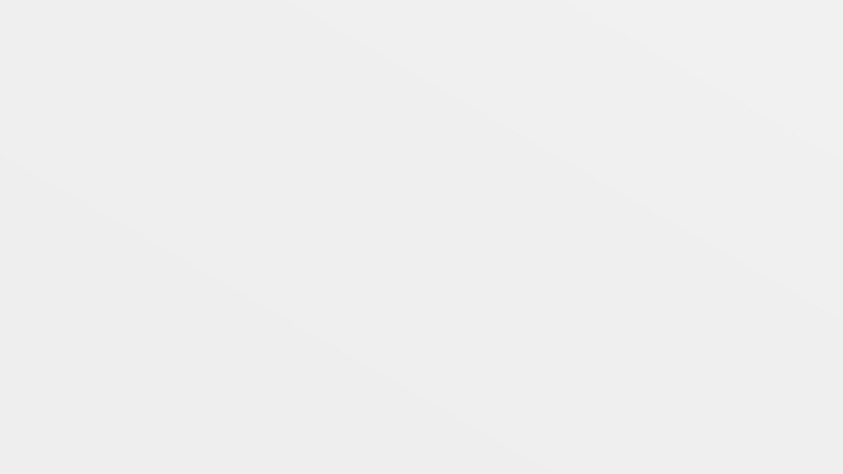

Homepage (Common) – User Guide

EDMS AMO Team

Nissan Internal

Table Of Contents
- Introuction

- Pre-requisites

- Functions on home page
①. Home
②. Browse
③.EDMS Advanced search
④.RL Advanced search
⑤.History
⑥.Favorites
⑦.Tasks
⑧.Reports
⑨.Clipboard
⑩.Trash
⑪.Bizadmin
⑫. Administration
⑬. Profile
⑭. FAQ
- User Guide(Homepage)
- Important tabs on Home Screen
①. System status tab
②. EDMS Specific Information Block
③. Regulation Library Specific Information Block

Nissan Internal

Introduction

Nissan Internal

- 1. EDMS - Introduction
The EDMS (Engineering Document Management System) is a vital application employed by the R&D department. It serves as a repository for various technical documents, including meeting minutes, materials, and records from major meetings, technical discussions, project management, cross-functional activities, events, and Nissan product developments. Additionally, it maintains a historical record of external contacts, such as suppliers, competitors, government agencies, associations, and others, used for research purposes.
An essential feature of the EDMS is the digitization and upload of legacy engineering documents, particularly the OED papers, which serve as reference materials within the R&D department. The EDMS grants access to approximately 45,000 users across different regions (NML, NTC, NS, JT, Autech, NATV, NMUK, RNTBCI, NTCNA).

Nissan Internal

Pre-requisites

Nissan Internal

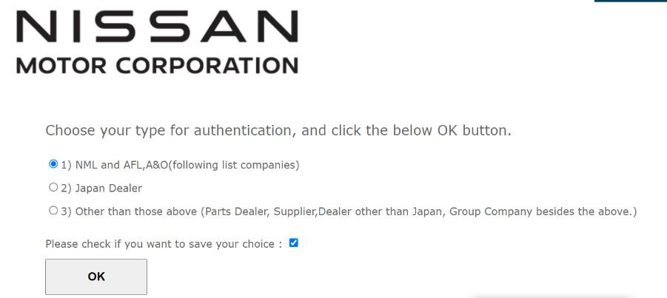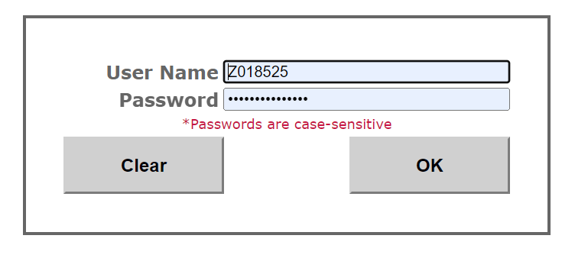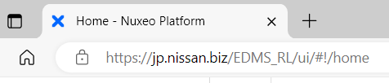2-1. URL & signing in

Step 1: Access URL : https://jp.nissan.biz/EDMS_RL/
Step 2: Only at first time you login, the screen below may appear. Please select 1 as below.

Step 3: Input your GD user ID and password. Then click OK. And now you will enter system.

To Logout, just click on “x” button in the browser to close the portal. No need for sign out.

Nissan Internal

2-2. How to change the language
Step 1: Click on the below Icon in your browser: Step 2: Go to settings.

Step 1:Click on this icon

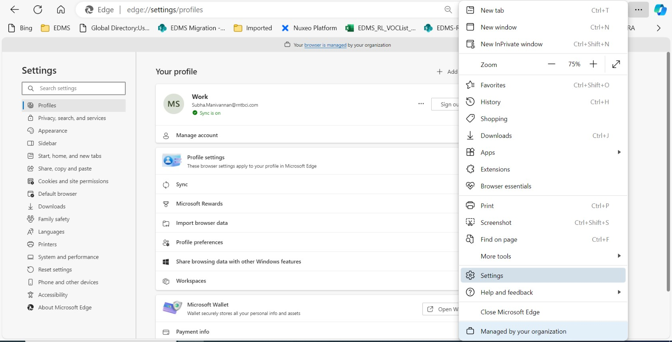

Step 2: Go to Settings

Step 3,4: Go to languages and move the required language to top.

Nissan Internal

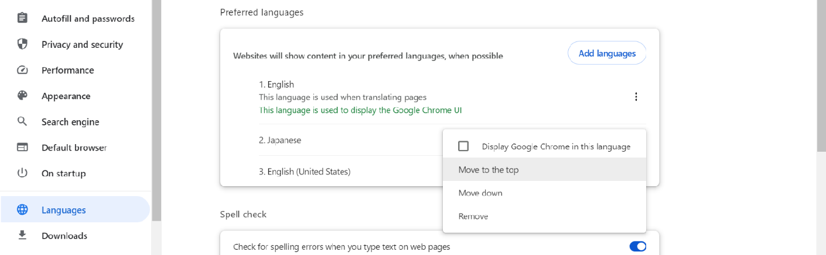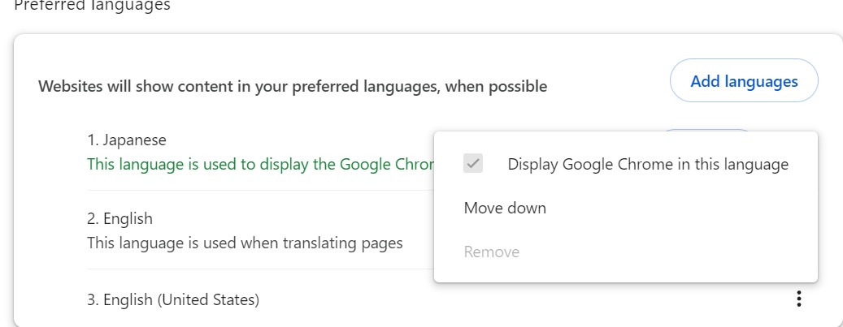
Step 4: Move the required language to the top

Step 3: Select languages.

Step 5: Tick mark the below option

Step 5: Tick mark this option

Step 6: Click on the Relaunch button.

Nissan Internal

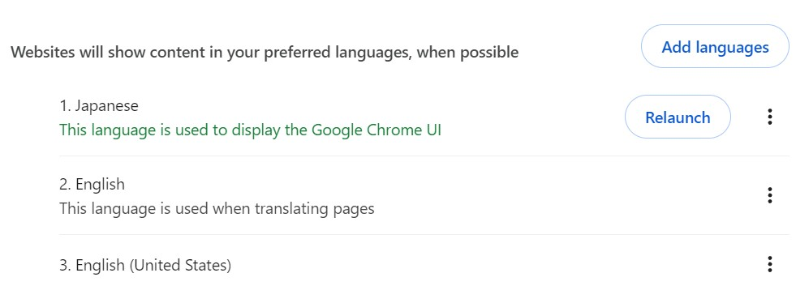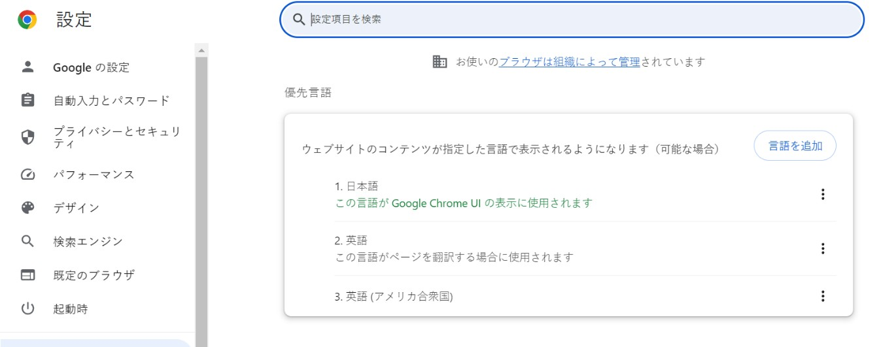.

Step 6: We will get a Relaunch button, click on this button.

The Page appears in the selected language.

Nissan Internal

Functions on Homepage

Nissan Internal

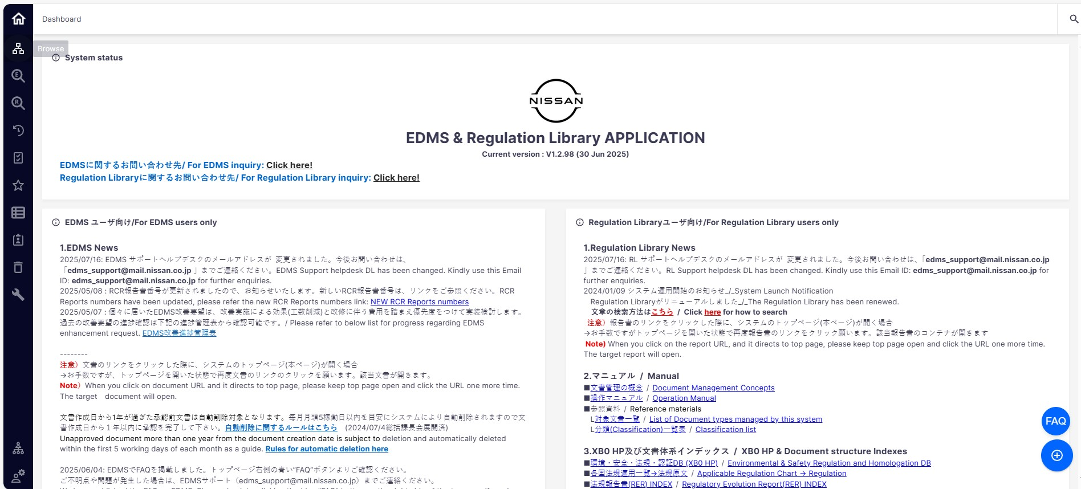3. Functions on Homepage
① Home
② Browse

③ EDMS
Advanced Search
④ RL Advanced
Search

⑤ History

⑥ Tasks
⑦ Favourites

⑧ Reports

⑨ Clipboard

⑩ Trash

⑪ Bizadmin
⑭ FAQ
⑫
Administration

⑬ Profile
Nissan Internal

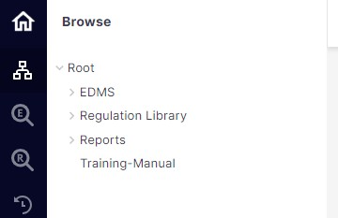① Home: Clicking this icon takes the user back to the app's homepage, which serves as a central hub for accessing various functions and features.
② Browse: This icon leads the user to the "Browse" page, where he can manage his personal workspace.
The user can view the different documents / files according to the category. This is also where he can add
/ View / modify / Delete documents.

Click

Nissan Internal

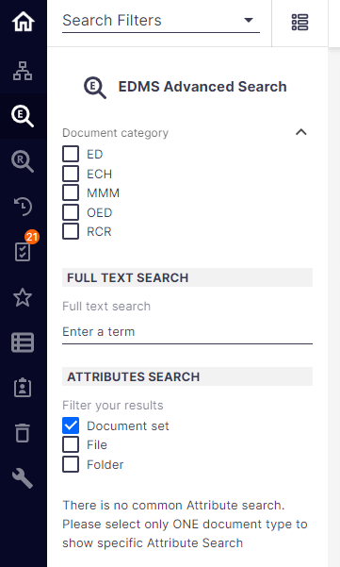③EDMS Advanced search: By clicking on this icon, the user accesses the Search for EDMS documents and files.
Here, users can perform advanced searches for specific documents or files based on various criteria, such as keywords, document type, author, date, etc.

Click

Nissan Internal

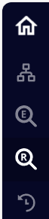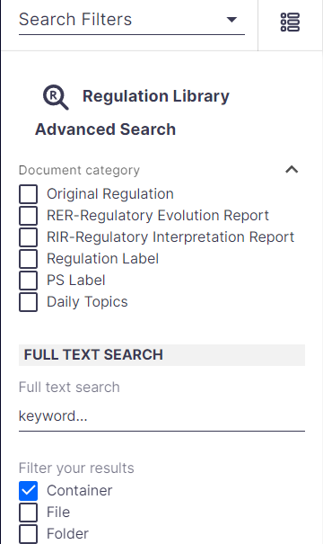④RL Advanced search: By clicking on this icon, the user enter the "Regulation Library Search" page
Here, users can perform advanced searches for specific documents or files based on various criteria, such as keywords, document type, author, date, etc.

Click

Nissan Internal

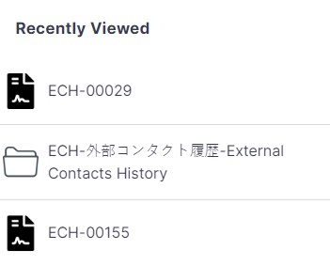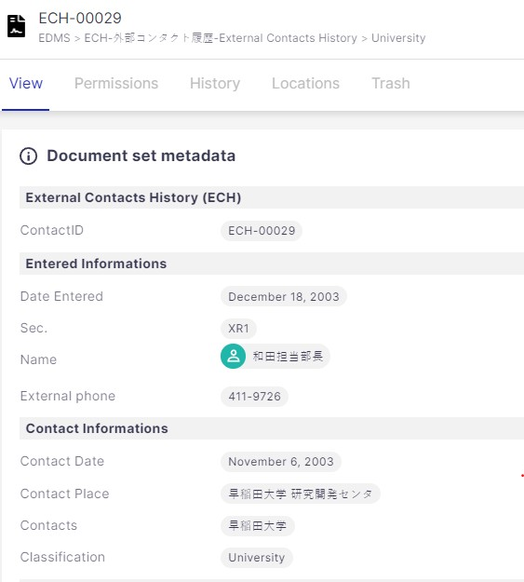⑤ History:This icon directs the user to the "History View" page, which displays recently accessed documents or files in the application.

Click

Further click an item, for example "ECH-00029", its page will be opened on the right.

Nissan Internal

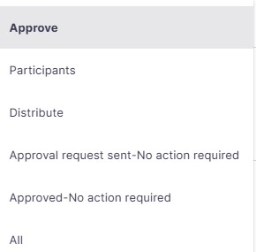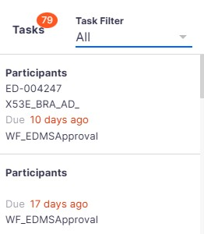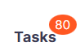⑥ Tasks: This icon gives access to the Tasks menu, it is here that you can see the list of tasks to be performed.
When it's the user's turn to take action during an approval workflow, this displays as a task.

Select from the ①
dropdown menu
②
③
④
⑤
⑥

① Approve : Lists the documents which are waiting for user’s approval. Once approved, the document set will not be displayed here.
② Participants : Lists the documents in which the workflow process is started by the creator and the approver not yet added (i.e., the approval request not yet sent to the approver).
Nissan Internal

③ Distribute : Lists the documents in which the user is set as a part of distributors list.
④ Approval sent – No action required : Lists the documents for which the workflow process is
submitted, approval requests are sent, and the approver must approve the request to proceed further.
⑤ Approved – No action required : Lists the set of approved documents.
⑥ All : Lists all the tasks.

Nissan Internal

⑦Favourites: By clicking on this icon, the user accesses the "Favorites" page, where he can view a list of documents or files that he has marked as favorites.
The page allows quick access to important content that the user frequently refers to.
Click on the document set to access the document.
Click

Steps to add to Favorite: click on the document you want to add to your favorites.

Click on ☆ to add it as favorite.

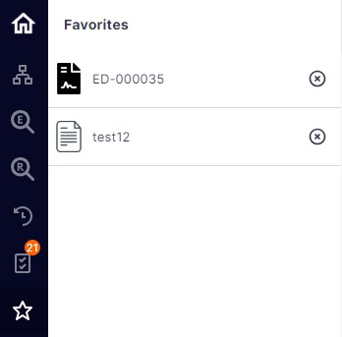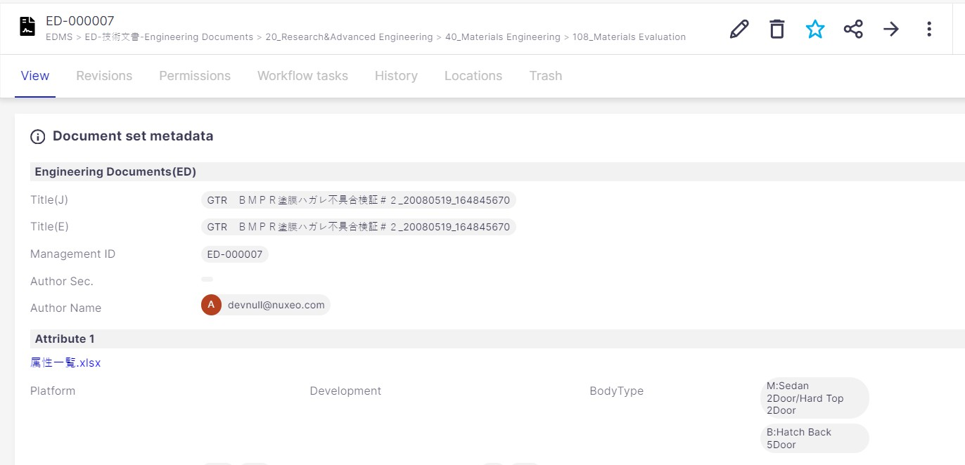

Nissan Internal

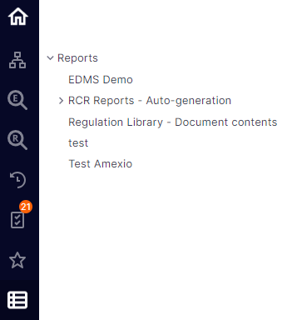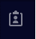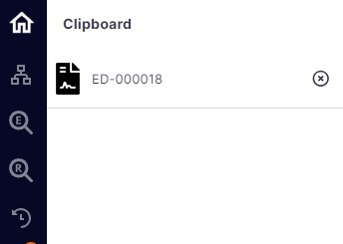⑧ Reports: It will be possible to create files as well as create reports inside.

Click

⑨Clipboard: The clipboard lets you easily copy or move any document set/file from one location to another(Workspace/folder).By clicking on this icon, a user can access to the menu where he will find the elements that he has added to clipboard.

Click

Nissan Internal

How to add to Clipboard:

Click

On the left menu, Clipboard shows there is item newly added.

How to remove from Clipboard:

After clicking the menu, you can find the document added.
You can further click the document to enter its Detailed page.

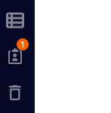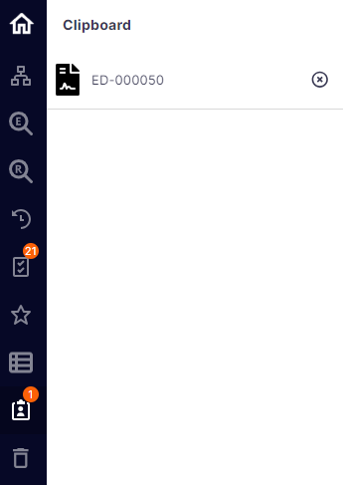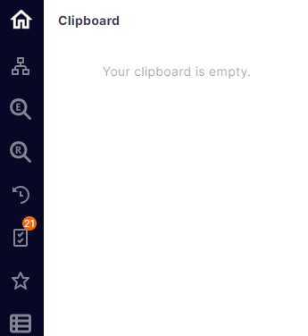

If click this x icon

The document will be removed from Clipboard

Nissan Internal

How to move to another folder from Clipboard:

- Add the document set
or file which you want to
move to a Clipboard

- Select the folder you
want to move to

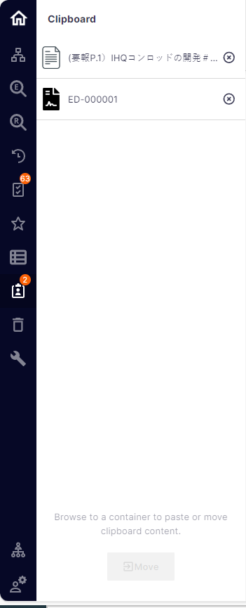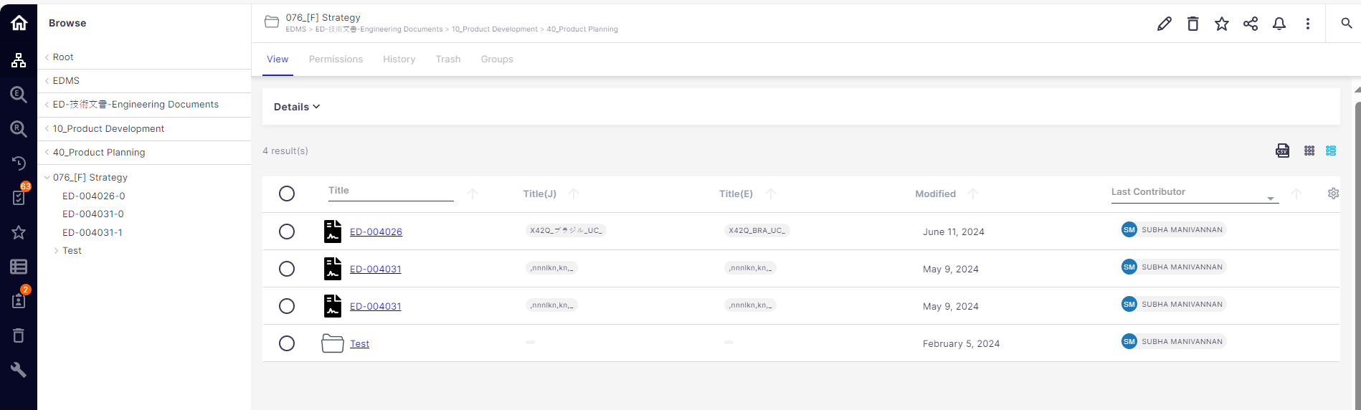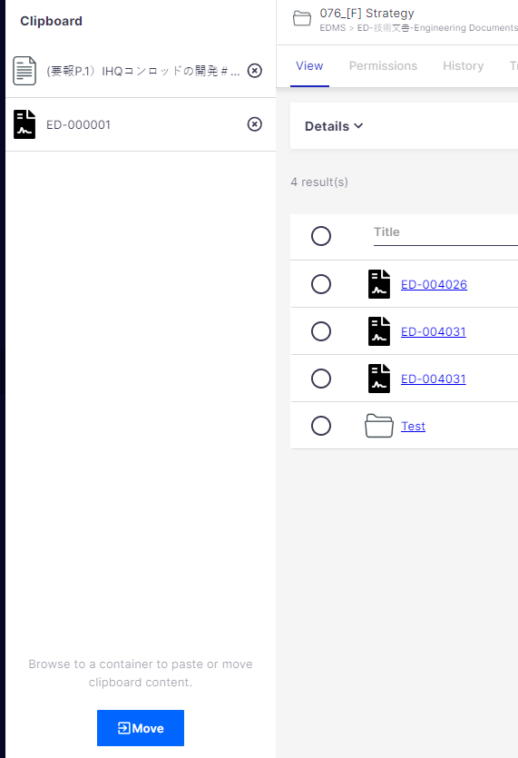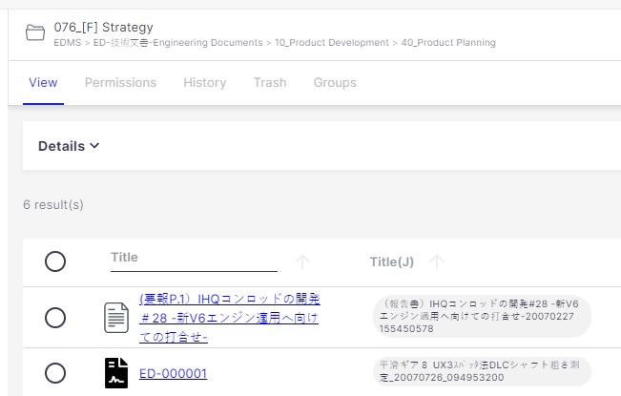
- Click on Move from Clipboard
- The File and Document set got
moved.
Nissan Internal

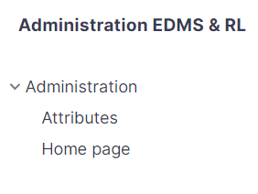⑩Trash: Clicking on this icon takes the user to the "Trash" page, which serves as a temporary storage area for deleted documents or files. Users can review and recover items from the Recycle Bin if needed before they are permanently deleted from the app.
⑪Biz Admin Tool: This block is only available for Administrator.

Ⓐ
Ⓑ

Ⓐ Attributes: We can edit / update the attributes.
Ⓑ Home Page: In this option, we can edit the view of homepage.

Nissan Internal

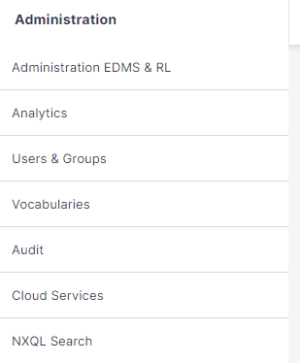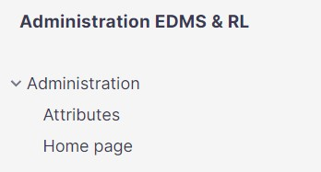⑫ Administration:As part of the administrators of the application, only IS/IT Admin and Biz Admin can see this icon on left menu.

Ⓐ
Ⓑ
Click Ⓒ
Ⓓ
Ⓔ

Ⓐ Administration EDMS & RL: We can edit attributes and homepage using this option.

Nissan Internal

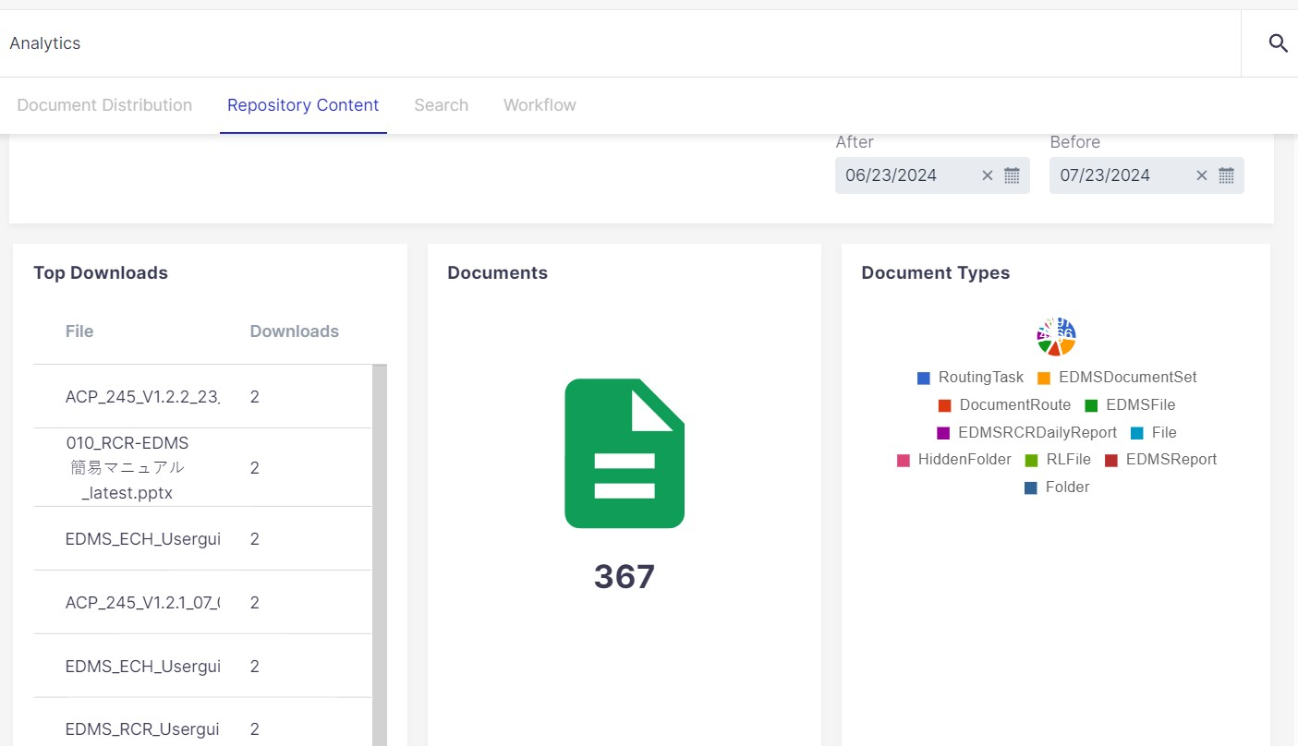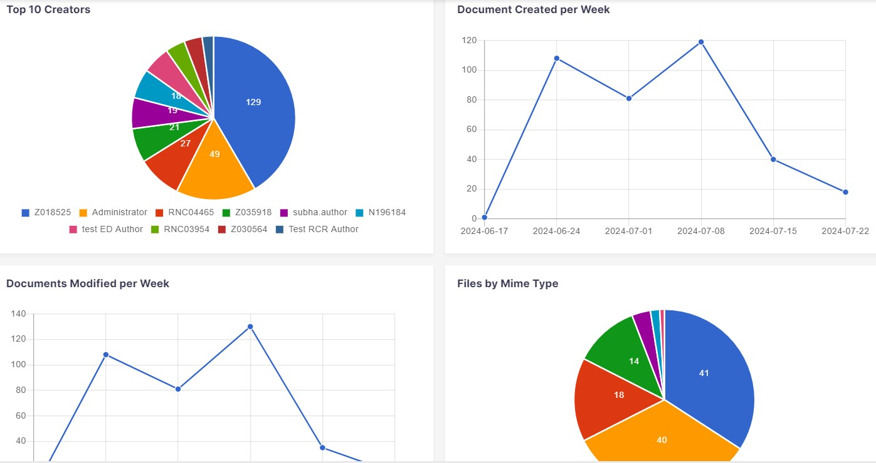Ⓑ Analytics: An Administrator can view various access logs and details regarding the usage
in this block.

Nissan Internal

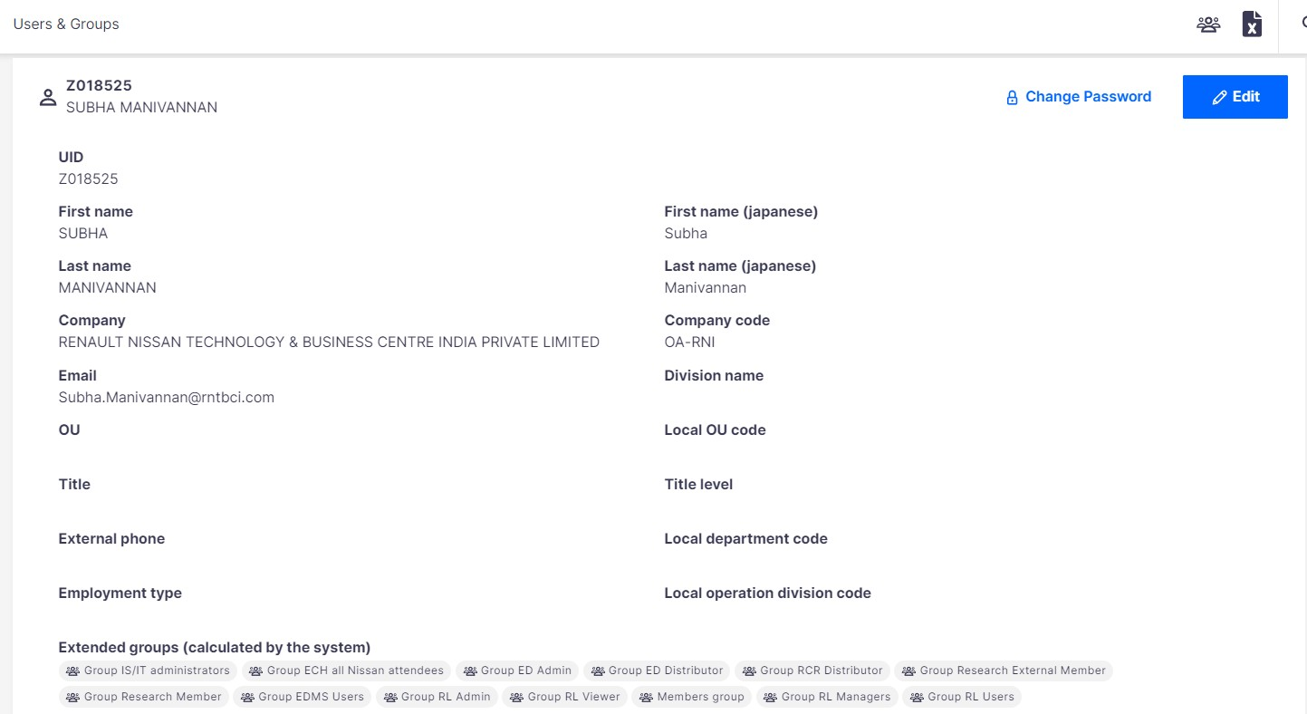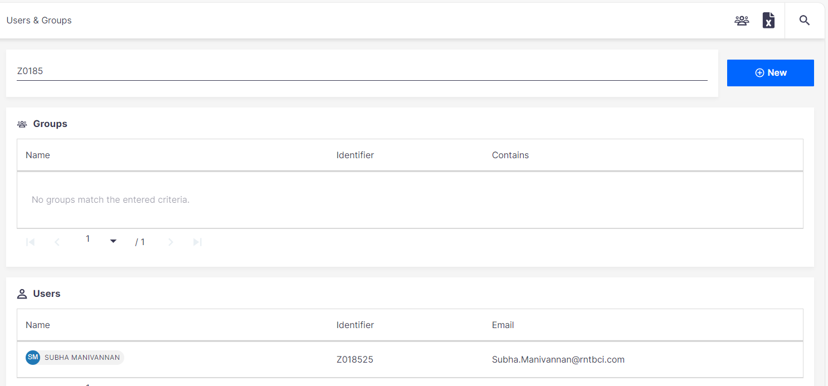Ⓒ Users and Groups: An administrator can create/delete a user/group in this block.
Also, he can perform all other Group management tasks in this tab like assigning/removing the user to/from the group. User details (eg: name, Department code) can be viewed here.

Nissan Internal

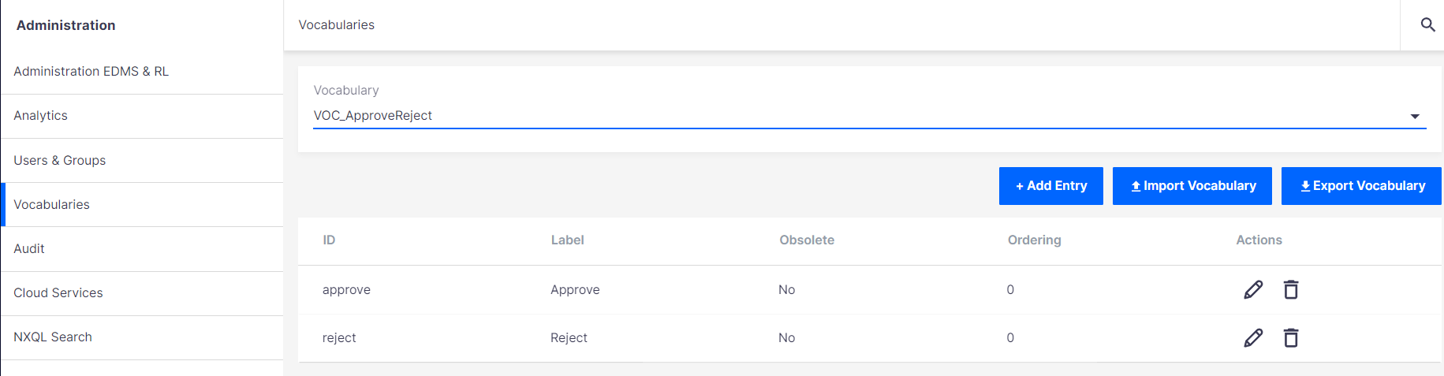Ⓓ Vocabularies : An administrator can import/export/edit the Vocabulary items/lists.

Ⓔ Audit: An Administrator can view the log details in this tab.

Nissan Internal

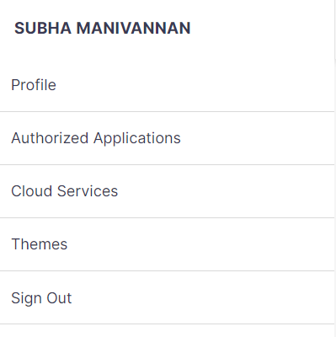⑬Profile (User Settings): We can access various user settings and options to customize our app in this section.

Ⓐ

Ⓑ
Ⓒ

Nissan Internal

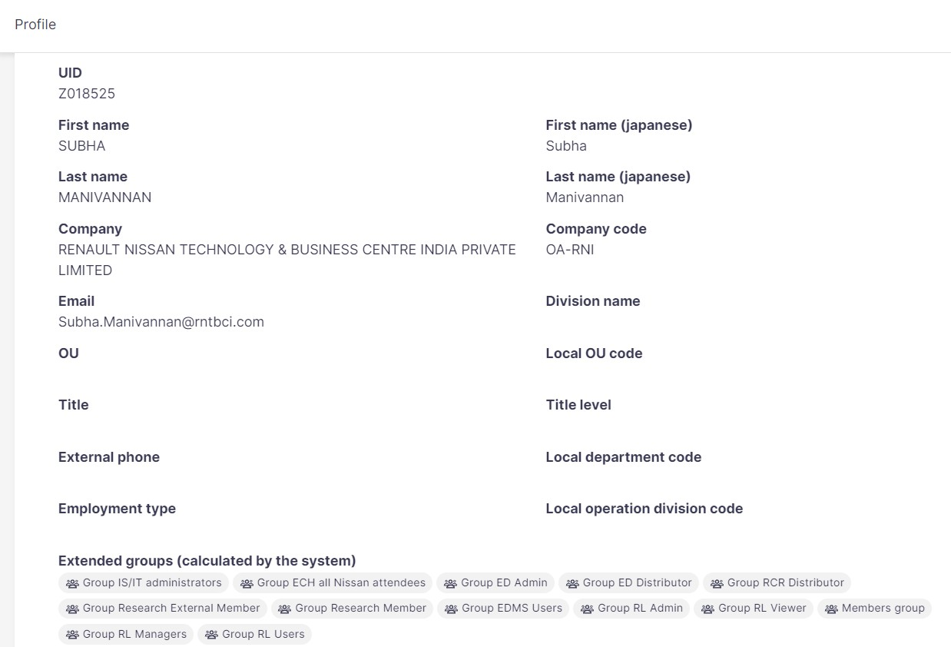Ⓐ Profile
The "Profile" tab allows you to view and manage your user profile. Here you can review your personal information, update your contact information, if necessary, and make changes to any other profile-related settings.
You can also see the groups you belong to as well as see all the permissions you have.

Nissan Internal

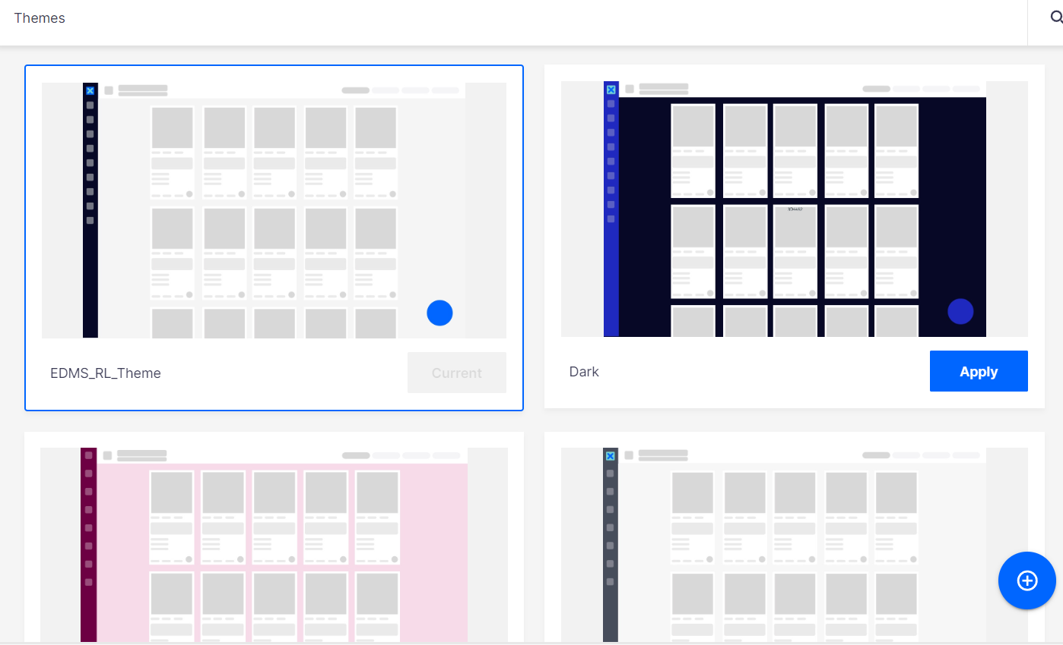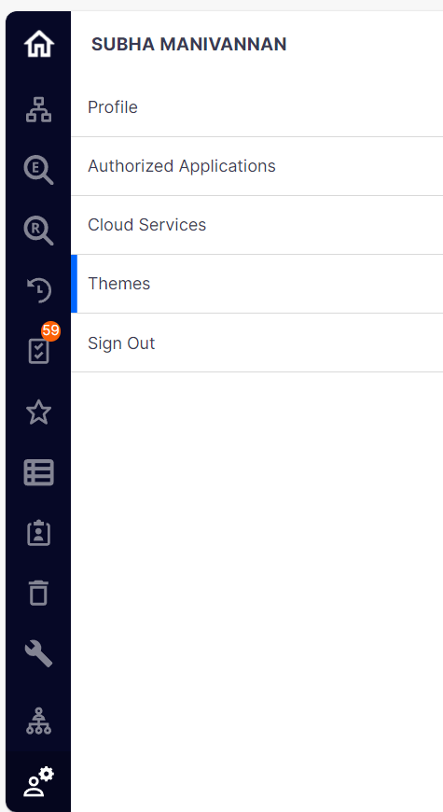Ⓑ Themes:
The "Theme" tab, located under the profile settings, offers the possibility to customize the appearance of your application.
You can choose from a range of pre-made themes or create a custom theme, adjusting colors, layouts
and other visual elements to suit your preferences.

Ⓒ Sign Out : By clicking it, you can safely log out of the application, ending your current session.

Nissan Internal

⑭FAQ : This acts as a knowledge database.We can access various frequently asked questions across all categories from here.

Click here to access FAQ
- Select the language

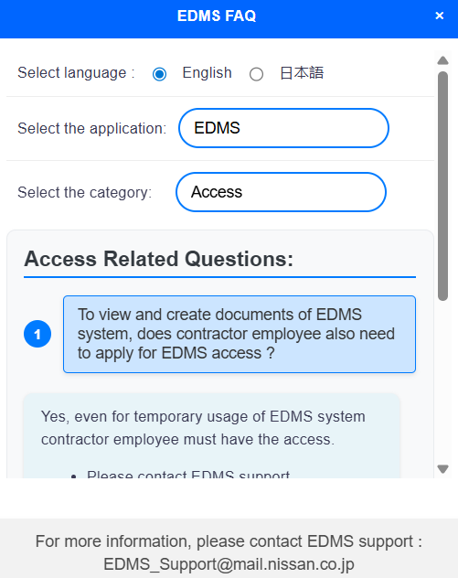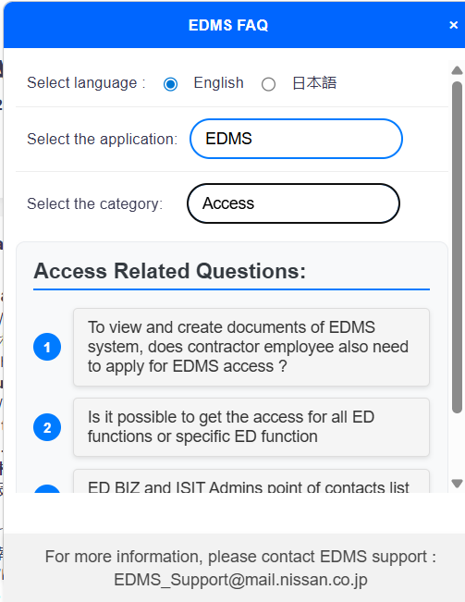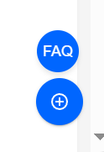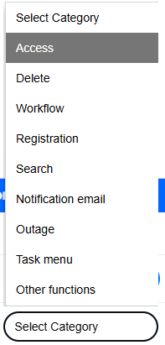

- Select EDMS
application

- Select the required topic from the dropdown

3. Select the required question and the answer will be displayed below.

Nissan Internal

4. Important tabs on Home screen

Nissan Internal

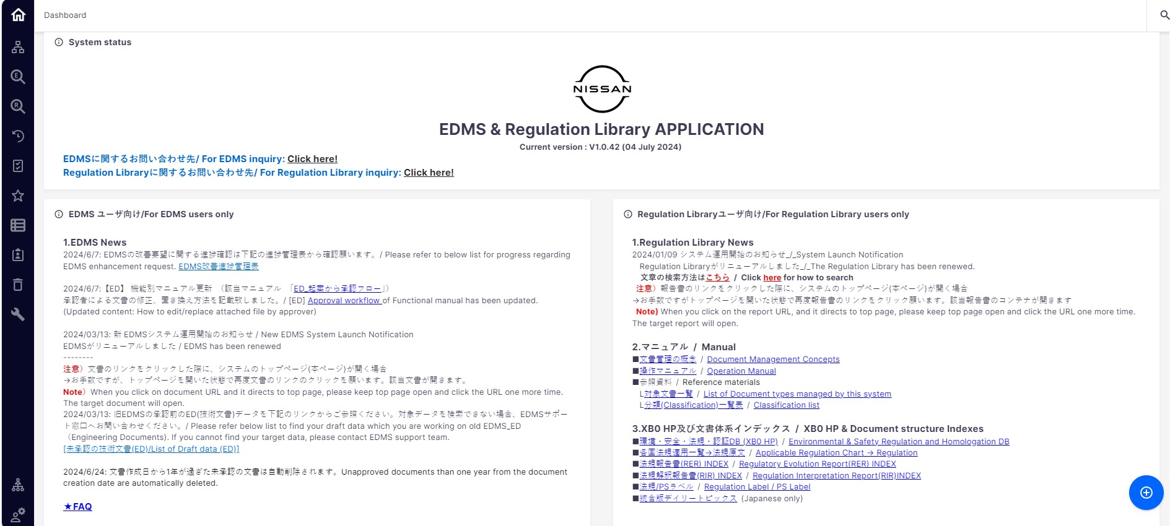4. Important tabs on Home screen

① System Status Block

②EDMS specific information block ③ RL specific information block
Nissan Internal

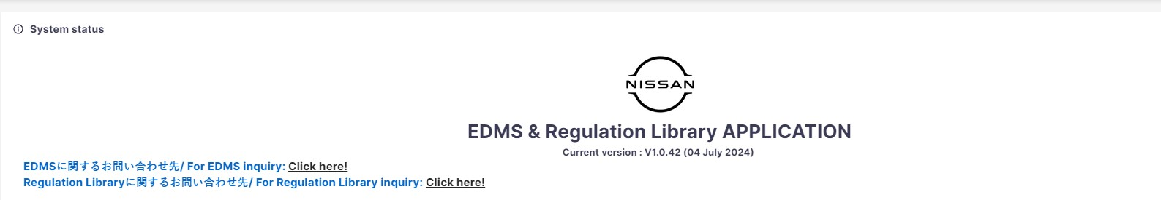① System Status Block: The “System Status” block is visible to all users and is created and managed by administrators. This block displays important system-wide announcements, notifications, or any other critical information that all users should be aware of. It serves as a communication channel between the administration and the entire user base.

Nissan Internal

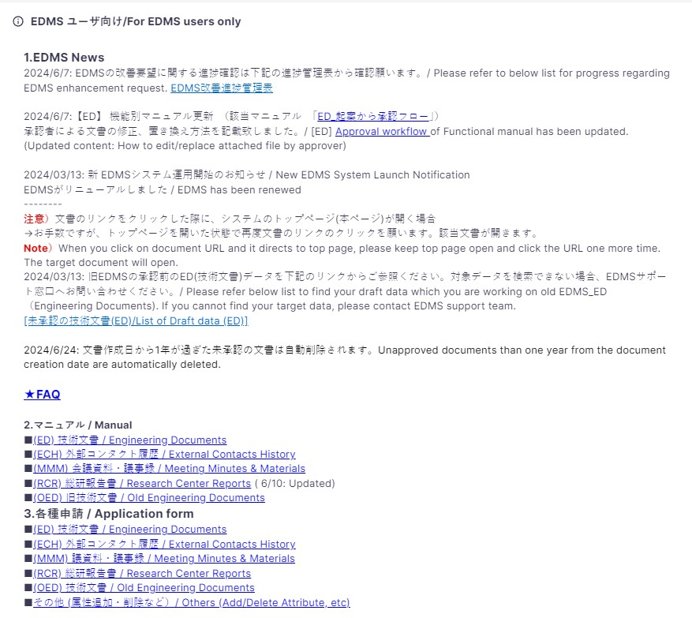② EDMS Specific Information Block: This block is displayed only for EDMS users. It serves as a communication channel between the administration and the entire user base. System use this block to display notifications, news, useful links, etc. in EDMS.

Nissan Internal

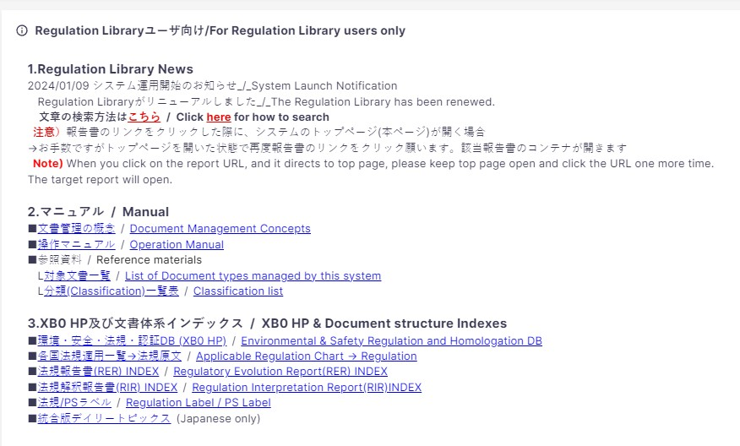③ Regulation Library Specific Information Block: This block is displayed only for users with Regulation Library permission. System use this block to display notifications, news, useful links, etc. in Regulation Library.

Nissan Internal

Thank you

Nissan Internal

